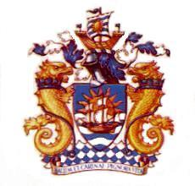
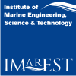

The Hong Kong Joint Branch of  The Royal Institution of Naval Architects  and The Institute of Marine  Engineering, Science & Technology | The Hong Kong Institute of  Marine Technology

Dear Member - You are cordially invited to join our

Joint Chairman Cocktail Reception

Date : Wednesday, 26 June 2013 from 6:30 p.m to 9:00 p.m.

Venue : The Gun Room

Royal Hong Kong Yacht Club, Kellett Island, Hong Kong,

Phone: 2832-2817.

Fee : HK$150.- per person

Dress : Smart Causal

Programme : 6:30 p.m. Cocktail Reception begins
7:30 p.m. Short Address by both HKJB and HKIMT Chairman
9:00 p.m. End of Function
Contact Person : Mr. Nelson Yu, Chairman
Public-Social Relations Sub. Committee,
HKJB of RINA & IMarEST
(Tel. : 2997 6828 ,Fax. : 2997 6838)

Come & Join Us By Returning The Reply Slip For A Great Social gathering

